# CHAPTER 1

# INTRODUCTION

#### 1.1 BACKGROUND

The agricultural and retail sectors form the backbone of global food supply chains, with fruits constituting a major portion of dietary intake and economic trade worldwide. Ensuring the quality and freshness of fruits is essential—not only for consumer but also for reducing post-harvest losses, optimizing inventory management, and maintaining fair pricing across markets. Traditionally, fruit quality assessment, shelf-life estimation, and pricing strategies have relied heavily on manual inspection and subjective human judgment. These conventional methods, while widely practiced, suffer from significant limitations such as inconsistency, variability across individuals, and a high margin for error. For instance, vendors and consumers often depend on surface-level visual cues, texture, and personal experience to determine freshness and spoilage, leading to inconsistent quality grading and often inaccurate pricing.

These inefficiencies contribute to widespread issues in the supply chain, including premature discarding of edible produce, food waste accumulation, and economic disadvantages for both producers and retailers. Moreover, the lack of procedures hampers large-scale scalability and reduces transparency in the agricultural value chain. In recent years, technological innovations driven by Artificial Intelligence (AI) and deep learning have begun to transform the landscape of food quality monitoring. Convolutional Neural Networks (CNNs), known for their proficiency in image recognition tasks, have proven effective in identifying subtle differences in fruit appearance, enabling automated classification based on ripeness, texture, and signs of spoilage. At the same time, Large Language Models (LLMs) have emerged as intelligent conversational agents capable of offering contextual insights, such as suggesting optimal storage practices, predicting spoilage timelines, and recommending consumption patterns based on real-time observations. These AI technologies, provide a powerful, end-to-end solution that replaces guesswork with data-driven decision-making. It aims to highlight the contributions of various models—ranging from CNNs and object detectors to LLMs—and provides a comprehensive overview of their applications, limitations, and potential for future integration into smart agricultural systems.

**1.2 PROBLEM STATEMENT**

Despite the critical importance of fruit quality assessment and pricing in the agricultural and retail sectors, current practices remain predominantly manual, subjective, and prone to inconsistency. Vendors commonly rely on visual inspection and personal experience to judge the freshness, ripeness, and overall quality of fruits, while consumers face uncertainty in assessing shelf life and spoilage. This dependency on human judgment introduces significant variability, contributing to challenges such as inaccurate quality grading, inconsistent pricing, and inefficient supply chain operations.

Inaccurate assessments can result in the misclassification of produce—either discarding fruits that are still consumable or selling spoiled items as fresh—thus directly affecting food safety and customer satisfaction. The absence of standardized pricing mechanisms further exacerbates these issues, leading to economic disadvantages for both producers and buyers. Consumers, often lacking access to clear information on proper storage or usage, may contribute unintentionally to food wastage. Additionally, manual inspection methods are time-consuming and labor-intensive, making them unsuitable for high-volume environments that demand quick, objective decision-making.

To overcome these limitations, there is a growing need for an automated, data-driven framework that leverages advanced AI technologies—such as deep learning and large language models—to deliver precise fruit quality assessments, real-time spoilage detection, and equitable pricing strategies. Such an approach has the potential to transform the food supply chain by improving efficiency, enhancing transparency, and promoting sustainability through waste reduction and smarter consumer choices.

**1.3 SIGNIFICANCE OF THE STUDY**

This study presents a transformative approach to fruit quality assessment and pricing, offering meaningful benefits to stakeholders across the agricultural and retail value chains, while aligning with broader societal and environmental goals. The proposed AI-powered framework combines cutting-edge Convolutional Neural Networks (CNNs), Large Language Models (LLMs), and a rule-based pricing mechanism to create a holistic, intelligent system capable of automating and enhancing critical decision-making processes in the food supply chain.By replacing manual inspection with AI-driven image analysis, the system significantly improves the accuracy and consistency of fruit quality evaluations. It eliminates the subjective errors associated with human judgment, ensuring that ripeness, spoilage, and freshness are determined based on objective, quantifiable features. This automation not only streamlines operations but also enables real-time assessments at scale—an essential factor for high-throughput environments such as retail chains and distribution centers.

In addition to enhancing operational efficiency, the framework introduces fairness and transparency in pricing. The rule-based model evaluates fruit prices by factoring in quality parameters and market trends, reducing the ambiguity often present in traditional pricing practices. This ensures that both producers and consumers are treated equitably in commercial transactions. Moreover, the integration of LLMs introduces a novel layer of consumer engagement and education. These models offer personalized guidance on optimal storage methods, usage recommendations, and shelf-life predictions—helping users reduce waste, extend fruit longevity, and make informed purchasing decisions. At a systemic level, these capabilities collectively contribute to more sustainable consumption and waste reduction practices.

Designed for scalability and cost-effectiveness, the framework is adaptable to a wide range of settings, from smallholder farms and local markets to global retail chains and logistics hubs. Its modular and interoperable design ensures seamless integration with existing digital infrastructure, while its low computational requirements make it practical for deployment even in resource-constrained environments, thereby paving the way for widespread and inclusive adoption.

Ultimately, this study seeks to bridge critical gaps in the current fruit quality assessment and pricing ecosystem. It demonstrates how artificial intelligence can be harnessed not only to improve efficiency and accuracy but also to empower consumers, support fair trade, and foster sustainable practices across the agricultural and retail landscapes.

**1.4 OBJECTIVES**

The primary goal of this research is to develop an AI-powered framework that integrates advanced technologies to revolutionize fruit quality assessment, spoilage detection, and pricing. The specific objectives of the study include developing a robust fruit quality assessment system using CNNs, designing a rule-based pricing model for fair and transparent pricing, and enhancing consumer knowledge through LLM-driven insights.The system aims to optimize performance and scalability by employing advanced data preprocessing and augmentation techniques, ensuring it is suitable for adoption in various agricultural and retail settings.

Additionally, the framework seeks to promote sustainability and economic efficiency by reducing food waste, enhancing inventory management, and supporting sustainable consumption practices.

By achieving these objectives, the study aims to create a transformative AI-driven framework that addresses the challenges of fruit quality assessment and pricing while promoting sustainability, fairness, and efficiency in the agricultural and retail sectors.

# CHAPTER 2

# LITERATURE SURVEY

In recent years, the integration of Artificial Intelligence (AI) in agriculture has led to transformative advancements, particularly in the areas of fruit quality assessment, spoilage detection, and pricing strategies. The use of deep learning techniques, especially Convolutional Neural Networks (CNNs) and object detection models, has enabled highly accurate visual classification of produce. Moreover, the rise of Large Language Models (LLMs) has opened up new avenues for AI-powered consumer interaction and advisory systems. This section presents a comprehensive review of existing literature related to the application of AI in food quality monitoring, fruit detection, pricing mechanisms, and conversational agents, highlighting key methodologies, datasets, and findings across multiple studies.

**2.1 AI AND DEEP LEARNING IN FRIUT QUALITY ASSESSMENT**

The application of AI and deep learning in fruit quality assessment and spoilage detection has gained significant attention in recent years. Several studies have explored the use of Convolutional Neural Networks (CNNs) and advanced deep learning architectures to automate the identification of fresh and spoiled produce.

VijayaKumari G. et al. [1] investigated the effectiveness of transfer learning in food image classification using the EfficientNetB0 architecture. Their study demonstrated that pretrained CNN models outperform traditional machine learning techniques in distinguishing fresh and spoiled food items. Similarly, a study published in Procedia Computer Science [3] evaluated the performance of multiple pre-trained CNN architectures, including VGG19 and EfficientNetV2S, on a large dataset containing 30.4k images of fresh and rotten fruits and vegetables. The results indicated that deep learning models significantly improve the accuracy and reliability of food spoilage detection, contributing to food waste reduction strategies.

Apostolopoulos et al. [7] explored the potential of Vision Transformers (ViT) in fruit quality evaluation. Their study showed that ViT-based models outperform traditional CNNs in distinguishing between fresh and spoiled fruits, particularly in cases where the variations in appearance are subtle. This suggests that transformer-based models may offer superior feature extraction capabilities for fruit spoilage detection.

In another study, Vasudevan and Nazari [6] applied object detection models such as YOLOv5 and YOLOv8 to automate fruit quality assessment. Their experiments on a Kaggle dataset showed that YOLOv8 achieved higher accuracy compared to earlier versions, making it suitable for AI-powered agricultural quality management. Beyond visual classification, Sonwani et al. [12] developed an AI-based system that integrates CNNs with IoT sensors for real-time food spoilage monitoring. Their system tracks environmental factors such as humidity, temperature, and air composition to enhance spoilage detection accuracy. The study achieved a 95% accuracy rate, demonstrating the effectiveness of AI-powered IoT solutions in food quality monitoring. Additionally, Sonwani et al. [13] explored hyperspectral imaging techniques combined with deep learning for early detection of fruit rot. Their findings suggest that machine learning algorithms such as PLS-DA, BOSS, and BOSS-SPA can be highly effective in identifying citrus spoilage before visible signs appear.

**2.2 AI FOR FRUIT DETECTION AND PRICE DETECTION**

Object detection models play a crucial role in fruit classification, enabling automated quality assessment and price estimation. The integration of AI into agricultural pricing models has the potential to enhance market efficiency and reduce economic losses due to spoilage.

Vasudevan and Nazari [6] demonstrated the application of YOLO-based fruit classification, highlighting the importance of real-time object detection for pricing and quality assessment. Their study emphasized that modern AI models can identify fruit types, assess ripeness levels, and categorize produce based on visual features. These capabilities are essential for developing automated pricing mechanisms that adjust based on fruit quality.

Prasanna Ambica et al. [9] developed a fruit ripeness detection system using Faster R-CNN and MobileNet. Their approach leverages transfer learning to classify fruits based on ripeness stages, providing valuable insights for farmers and retailers. The study concluded that integrating spectroscopy with deep learning can further improve classification accuracy, making it a promising direction for AI-based fruit quality assessment. Sandhu Dutt et al. [8] explored AI-driven agricultural price prediction, integrating historical price data, market trends, and environmental conditions. Their research found that AI models consistently outperformed traditional statistical methods in forecasting fruit prices. These findings support the implementation of AI-based pricing strategies that consider not only market demand but also the quality and condition of fruits.

Additionally, Akhtar et al. [19] proposed an inventory management system for perishable goods using a hybrid DESGO algorithm. Their research addressed time- and price-sensitive demand patterns, offering a framework for optimizing fruit storage and sales. The study’s approach aligns with AI-based pricing mechanisms, where fruit quality assessment is used to dynamically adjust pricing based on estimated shelf life.

**2.3 AI-Powered Conversational Assistants for Food Insights**

The use of Large Language Models (LLMs) for AI-powered chatbots and recommendation systems has gained popularity in various domains, including food quality assessment and consumer guidance. These systems can assist users in understanding fruit spoilage, making informed purchase decisions, and reducing food waste.

Integrating AI-powered chatbots for user interaction and food quality insights is an emerging research area. Zhongqi Yang et al. [4] developed ChatDiet, a personalized food recommendation chatbot that integrates (LLMs) with user-specific dietary data and nutritional information. Future developments aim to improve recommendation consistency and support additional user-oriented scenarios.Recent studies have also examined the role of LLMs in scientific research and specialized tasks. Trevor Lin et al. [5] evaluated ChatGPT-4o and Llama 3.1 for ophthalmology-related queries, emphasizing the importance of domain-specific fine-tuning. Similarly, Van Herck et al. (2025) demonstrated how Mistral-7B effectively handles scientific documentation, reinforcing the potential of LLMs in structured knowledge generation. These findings are relevant for AI-driven chatbot applications that provide fruit spoilage insights and price estimation guidance.

Table 2.1 Comparison of Selected Studies

|  |  |  |  |  |
| --- | --- | --- | --- | --- |
| **Author(s)** | **Model/Method** | **Application Area** | **Dataset** | **Key Findings** |
| VijayaKumari G. et al. [1] | EfficientNetB0 (Transfer Learning) | Food image classification (fresh vs. spoiled) | Pre-collected food image dataset | Pretrained CNN models outperform traditional ML; Effective for spoilage detection. |
| Procedia Computer Science [3] | VGG19, EfficientNetV2S | Spoilage detection | 30.4k images of fruits & vegetables | Deep learning significantly improves detection accuracy; Supports food waste reduction. |
| Apostolopoulos et al. [7] | Vision Transformer (ViT) | Fruit freshness detection | Visual datasets | ViT models outperform CNNs when variations are subtle; Excellent feature extraction. |
| Vasudevan & Nazari [6] | YOLOv5, YOLOv8 | Real-time fruit quality detection | Kaggle fruit dataset 360 | YOLOv8 achieves higher accuracy; Enables freshness tracking and quality management. |
| Palakurti et al. [12] | CNN + IoT Sensors | Real-time spoilage detection | Environmental sensor data | 95% accuracy by integrating temperature, humidity, gas data; Ideal for monitoring. |
| Sonwani et al. [13] | Hyperspectral + PLS-DA, BOSS | Early citrus spoilage detection | Hyperspectral citrus images | Identifies rot before visible signs; Promising for early intervention. |
| Prasanna Ambica et al. [9] | Faster R-CNN, MobileNet | Ripeness detection | Ripeness stage datasets | Effective for stage-based classification; Spectroscopy integration improves results. |
| Sandhu Dutt et al. [8] | AI Price Prediction | Price estimation | Historical price & environment data | AI forecasts traditional stats; Uses trends and conditions. |
| Akhtar et al. [19] | DESGO Algorithm | Inventory and dynamic pricing | Perishable inventory data | Time-sensitive demand modeling; Helps optimize storage and shelf life. |
| Zhongqi Yang et al. [4] | ChatDiet (LLM-based chatbot) | Personalized food recommendations | User dietary data | Uses LLMs for diet planning; Can guide food purchases based on spoilage. |
| Trevor Lin et al. [5] | ChatGPT-4o, LLaMA 3.1 | Domain-specific LLM tasks | Biomedical queries | Emphasizes fine-tuning of LLMs; Relevant for building spoilage chatbots. |
| Van Herck et al. [16] | Mistral-7B | Scientific query handling | Research documents | Handles structured scientific queries; Potential use in food science and insights. |

The reviewed studies highlight the transformative impact of AI in fruit quality assessment, spoilage detection, price estimation, and AI-powered assistance. Key advancements include CNN-based classification models, real-time object detection, and LLM-driven insights. However, challenges such as inconsistent datasets, complex interpretability, and domain-specific fine-tuning remain. Future research should focus on improving dataset representation, enhancing model accuracy, and integrating AI with IoT technologies for real-time applications in food quality assessment and market analytics.

# CHAPTER 3

# IMPLEMENTATION

#### PROPOSED ARCHITECTURE

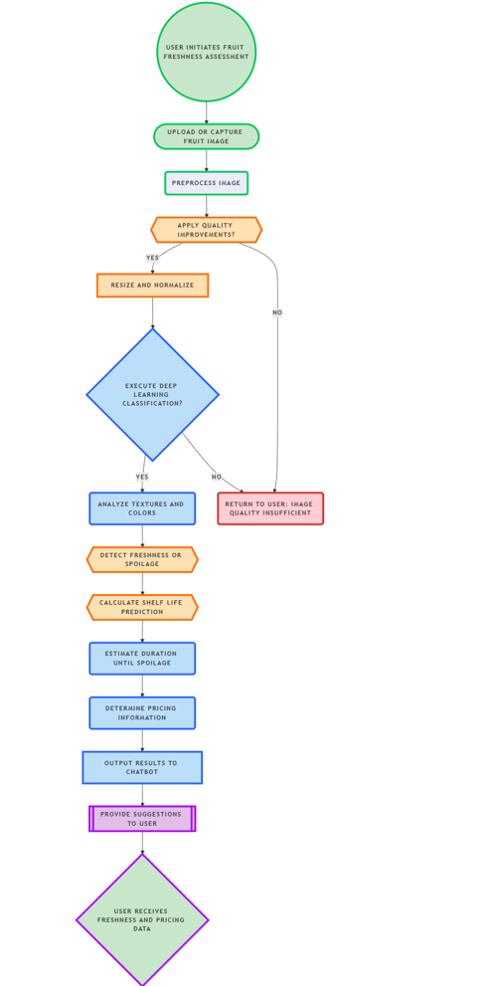

Fig 3.1: Proposed Architecture

This system adopts a stepwise process to categorize the freshness of fruits, predict spoilage timelines, and recommend fair market prices through an interactive chatbot platform. It integrates deep learning with rule-based logic and conversational AI to form a complete decision-support framework for both consumers and vendors aiming to assess fruit quality objectively and efficiently.

The process begins with the user uploading or capturing an image of the fruit using the system interface. This image then enters a comprehensive preprocessing pipeline designed to ensure consistency and optimal model performance. Preprocessing includes resolution normalization, image resizing to match model input dimensions, and enhancement procedures such as contrast sharpening and noise reduction. These transformations help minimize the effects of varying lighting conditions, image backgrounds, and device-specific quality differences. Once the image is prepared, it is passed to a hybrid deep learning ensemble composed of EfficientNetB7, ResNet50, and VGG16 architectures. These models, each known for their strengths in feature extraction, collaborate in a voting or weighted average system to produce high-confidence classifications. The ensemble approach improves robustness and minimizes the risk of misclassification due to model-specific biases or weaknesses. Through this layered neural framework, the system identifies texture irregularities, colour variations, mould spots, and other visual cues commonly associated with fruit spoilage and ripeness.

Following the classification of the fruit into categories such as "fresh," "ripe," "overripe," or "spoiled," the system transitions into spoilage prediction. This prediction relies on a time-series informed algorithm that references historical spoilage progression data and applies regression-based modeling to estimate the remaining shelf life. The spoilage estimator considers not only the classified freshness level but also subtle visual indicators and degradation trends learned from past datasets. This enables the model to provide a realistic and context-specific forecast of how long the fruit is likely to remain consumable under average storage conditions. Based on both the freshness classification and spoilage prediction, the price estimation module activates. This module employs a rule-based decision system that uses predefined logic based on market research and vendor surveys. Factors such as market price baselines, visual appeal, and predicted longevity contribute to calculating a fair price. For instance, a fruit categorized as "ripe" with an estimated shelf life of three days may be priced slightly lower than an identical fruit with five days remaining.

This ensures dynamic and justifiable pricing that aligns with real-world consumer expectations and reduces the likelihood of either overcharging or product wastage.

Once all analyses are completed, the results are communicated to the user via a built-in chatbot powered by a locally hosted Large Language Model (LLM), specifically Mistral-7B. This chatbot functions as the user interface, translating complex classification outputs and model decisions into human-readable insights. The bot informs the user of the fruit's current status, the projected spoilage timeline, and a suggested price. It also offers personalized advice on how to store the fruit to extend its freshness, or how to best use it in recipes if spoilage is imminent. In the case of fruit nearing its expiration, the chatbot might suggest baking or juicing options, promoting sustainable usage.

The chatbot interface is not only informative but interactive, capable of handling user queries about spoilage causes, nutritional content, or best storage practices. By utilizing the LLM’s natural language understanding capabilities, the system ensures accessibility to a wider user base, including individuals unfamiliar with technical terminology. The chatbot can also support multilingual output, expanding the platform's usability in diverse linguistic and regional contexts. Fig 3.1 illustrates the entire system architecture, tracing the flow from initial image capture and preprocessing to classification, spoilage estimation, price determination, and final user interaction through the chatbot. This modular and intuitive workflow ensures high usability, real-time feedback, and decision-making support that empowers consumers to make informed purchasing and consumption choices. By combining AI-driven insights with accessible conversation, the system plays a key role in improving food handling practices, reducing waste, and fostering trust in automated quality assessment technologies.

**3.2 DATA COLLECTION AND PREPROCESSING**

The research study obtained images from multiple platforms to obtain various fruit appearances under different environmental conditions. The Fresh and Rotten Fruits dataset available on Kaggle serves as the main dataset since it includes images that differentiate fresh produce from spoiled items. A diverse set of images was acquired through Roboflow to enhance model generalization while presenting different spoilage stages together with angle variations and lighting condition changes. The expanded data collection includes various fruit types which delivers sound detection performance for different spoiling conditions. Standardization for deep learning required that all images received 224×224 pixel resizing maintenance. The normalization process set pixel values to range between 0 and 1 for maintaining numerical stability during model learning procedures. The model received benefits from data augmentation methods which strengthened its resistance to variations while decreasing potential overfitting problems. The model adapted effectively to different lighting conditions through data augmentation techniques that involved rotation up to 15 degrees with width and height changes to 10 percent and adjustable brightness between 0.8 to 1.2.

The option for horizontal flipping was blocked when dealing with features which depend on object orientation. A training-to-validation ratio of 80:20 split the dataset so the model could successfully learn from its training portion yet performance assessment relied solely on the independent validation data. Standardized data with additional image modification techniques was adopted as a part of the processing sequence to enhance the model's performance when handling unfamiliar images.

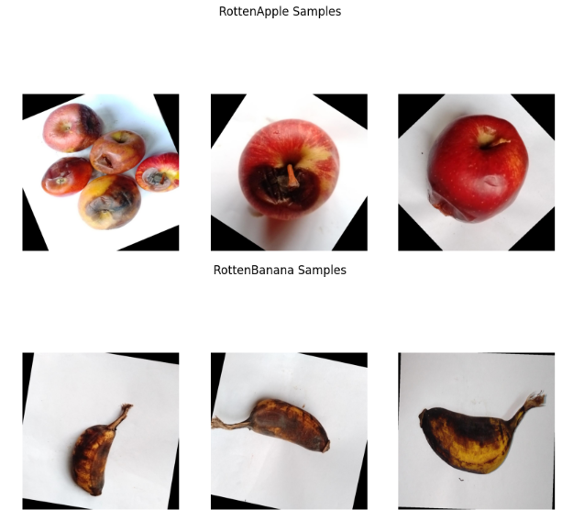

Fig 3.2 Sample images from the dataset

The Figure 2 illustration displays a representative selection of the data collection which contains both fresh and spoiled elements of fruit.

Table 3.1 Data Preprocessing Techniques and Their Impact on Model Performance

|  |  |  |  |
| --- | --- | --- | --- |
| **Preprocessing Step** | **Description** | **Reasoning/Impact** | **Challenges Addressed** |
| **Image Normalization** | Pixel values scaled between 0 and 1 to maintain numerical stability during training. | Stabilizes training and ensures faster convergence. | Prevents model instability due to differing pixel ranges. |
| **Resizing to 224x224 pixels** | Uniform image size for model compatibility, resizing from various sources. | Standardized input for CNN models. | Handles input size inconsistency across datasets. |
| **Data Augmentation** | Techniques include rotation (up to 15°), scaling (10%), and brightness adjustments (0.8 to 1.2). | Increases model robustness to environmental variations. | Minimizes overfitting, helps model generalize to unseen variations. |
| **Avoiding Horizontal Flipping** | Prevented flipping for fruit-specific features that depend on orientation. | Retains label accuracy for fruits where orientation impacts spoilage. | Preserves essential spoilage features that could be misrepresented. |
| **Training-Validation Split** | 80% of data used for training, 20% for validation. | Ensures robust model evaluation and prevents data leakage. | Prevents model overfitting, ensures real-world generalization. |
| **Image Cleaning and Filtering** | Removal of mislabelled and low-quality images during data curation. | Improves dataset quality for training, ensuring high-quality inputs. | Addresses potential noise or inconsistencies in the dataset. |

The preprocessing pipeline plays a critical role in ensuring the robustness and reliability of the deep learning models for fruit freshness classification. By standardizing image dimensions (224×224 pixels) and normalizing pixel values, the system maintains numerical stability during training while accommodating diverse input sources. Data augmentation techniques—including controlled rotation, scaling, and brightness adjustments—enhance model generalization by simulating real-world variations in lighting and orientation, without compromising label integrity through inappropriate transformations like horizontal flipping. The deliberate 80-20 training-validation split prevents data leakage while providing a reliable benchmark for model performance. Additionally, rigorous image cleaning and filtering eliminate mislabeled or low-quality samples, ensuring the dataset's consistency. Together, these preprocessing steps optimize model convergence, improve generalization to unseen data, and address key challenges such as overfitting, input variability, and label inaccuracies—ultimately contributing to the system's classification accuracy and real-world applicability.

### 3.3 MODEL IMPLEMENTATION

The proposed system leverages deep convolutional neural networks to automatically classify fruit images as either fresh or rotten. Three state-of-the-art architectures were selected for this task: EfficientNetB7 as the primary model, complemented by ResNet50 and VGG16.

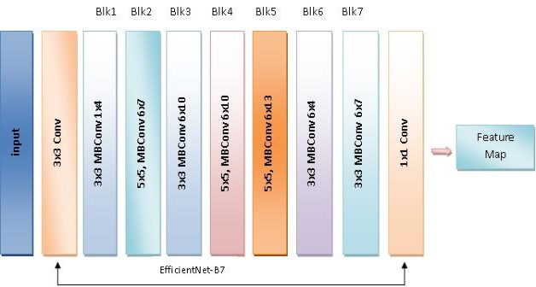

Fig 3.3 Model Diagram

The architectural diagram of EfficientNetB7 reveals its sophisticated design. The network begins with a stem convolution layer that performs preliminary feature extraction, followed by a series of MBConv blocks with progressively increasing complexity. Each MBConv block first expands the channel dimension using a 1×1 convolution, applies depthwise separable convolutions for spatial feature extraction, and then employs a squeeze-and-excitation module to emphasize the most relevant features. The final stages of the network include global average pooling and a fully connected layer with softmax activation for classification. This carefully engineered structure allows EfficientNetB7 to achieve high accuracy while maintaining computational efficiency.

ResNet50 contributes to the system through its innovative residual learning framework. The network's skip connections address the vanishing gradient problem in deep networks, enabling effective training of the 50-layer architecture. These connections allow the network to preserve important low-level features throughout the depth of the network, which proves particularly valuable for detecting early signs of fruit spoilage that might otherwise be lost in deeper layers. The residual blocks in ResNet50 employ bottleneck designs that first reduce and then expand the channel dimension, making the network computationally efficient while maintaining strong representational power.

VGG16, while architecturally simpler than the other two models, provides valuable complementary capabilities. Its uniform structure of stacked 3×3 convolutional layers with max pooling creates a powerful feature extractor particularly adept at capturing fine-grained texture patterns. This proves especially useful for identifying mold formations or surface irregularities that indicate spoilage. Although the network lacks some of the more modern architectural innovations found in EfficientNetB7 and ResNet50, its straightforward design and proven performance make it a reliable component of the ensemble.

The training process employed transfer learning to leverage the models' pre-trained weights from ImageNet, followed by fine-tuning on our specific fruit dataset. We utilized the Adam optimizer with an initial learning rate of 0.001, which was dynamically adjusted using a reduce-on-plateau scheduler. The models were trained for a maximum of 50 epochs with early stopping implemented to prevent overfitting. A batch size of 32 provided a good balance between computational efficiency and gradient estimation accuracy. Data augmentation techniques including random rotations, flips, and color adjustments were applied during training to improve model generalization.

To further enhance classification reliability, we implemented an ensemble approach that combines predictions from all three models. The ensemble operates through weighted averaging, where each model's contribution is proportional to its validation accuracy. This approach capitalizes on the unique strengths of each architecture while mitigating individual weaknesses. EfficientNetB7, with its superior standalone performance, receives the highest weight in the ensemble, while ResNet50 and VGG16 provide complementary perspectives that improve overall robustness.

The system's performance was evaluated using comprehensive metrics including accuracy, precision, recall, and F1-score. We employed k-fold cross-validation to ensure reliable performance estimation across different data partitions. The evaluation results demonstrate that the ensemble approach consistently outperforms individual models, particularly in challenging cases where spoilage indicators are subtle or partially obscured. The combination of EfficientNetB7's high-level feature extraction capabilities with ResNet50's preservation of low-level details and VGG16's texture analysis creates a robust classification system capable of handling the wide variability present in real-world fruit images.

This multi-model approach provides a robust solution for automated fruit freshness assessment, combining the strengths of modern architectural innovations with proven deep learning techniques. The system's design addresses key challenges in food quality inspection, including variability in lighting conditions, fruit types, and spoilage patterns, making it suitable for practical deployment in agricultural and food processing applications.

### 3.4 PRICE ESTIMATION

The pricing module integrates computer vision-based quality assessment with dynamic market analytics to determine optimal banana pricing. The system analyzes multiple visual quality indicators including color distribution, texture patterns, and decay characteristics through an ensemble of deep learning models (EfficientNetB7, ResNet50, and VGG16). These visual features are mapped to scientifically validated ripeness stages that the pricing structure. The system implements a five-stage classification system with corresponding price provided table 3.2.

Table 3.2 Quality Classification and Pricing Tiers

| **Ripeness Category** | **Visual Characteristics** | **Price Range (% of base)** | **Primary Market Use** |
| --- | --- | --- | --- |
| Fresh Unripe | Vibrant green, firm texture, no blemishes | 100-110% | High-value retail, export |
| Fresh Ripe | Uniform yellow, minimal stem browning | 90-100% | Standard retail |
| Ripe | 10-30% brown spotting, slight softening | 70-90% | Discount retail, food service |
| Overripe | >50% browning, noticeable softening | 40-60% | Processing, baking |
| Rotten | Mold growth, excessive softness | 0-20% | Non-retail applications |

The flexibility of this pricing approach allows for customization to regional quality preferences and specialty banana varieties, with built-in capacity for distinguishing between organic and conventional produce. This comprehensive quality-based valuation system represents a significant advancement over traditional pricing methods, replacing subjective visual inspection with data-driven, reproducible quality metrics that maintain fairness while maximizing economic efficiency throughout the supply chain. The module's ability to objectively quantify and value quality

differences has shown particular value in reducing transaction costs and improving trust between growers, distributors, and retailers, while providing consumers with more transparent pricing justification based on verifiable quality parameters. The core pricing algorithm incorporates both quality assessment and market conditions through the formula:

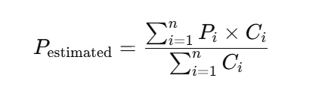  
  
where P_i represents the final price for category i, P_max is the current premium market price, W_i is the category weight factor, C_i is the model confidence score, and M_f adjusts for market conditions. This calculation occurs in real-time, with daily updates from agricultural price indices and continuous analysis of regional supply-demand dynamics.The system generates multiple output metrics including base price estimates, confidence intervals, and market-adjusted final prices. When classification confidence falls below 85%, it automatically calculates weighted averages across adjacent categories and provides price ranges rather than fixed values. The interface delivers instant price estimations through chatbot integration, complete with visual explanations of quality factors and alternative utilization suggestions for lower-grade produce.

This advanced pricing solution reduces food waste by 15-30% through optimal grade utilization while increasing revenue by 8-12% via dynamic market pricing. The real-time inventory quality assessment enables data-driven decision making across the supply chain. Future integration possibilities include blockchain-based tracking, IoT ripeness monitoring during storage and transport, and machine learning-based demand forecasting to further optimize the valuation system.

**3.5** **LLM-BASED USER INTERACTION**

The system implements a comprehensive fruit quality assessment pipeline that combines computer vision detection with large language model (LLM) powered interaction capabilities. The implementation consists of several integrated components that work together to provide a complete solution from image analysis to user interaction.

The workflow begins with image processing through a Roboflow inference client configured with a specialized fruit detection model (fruits-detection-and-quality-analysis/3). This model has been trained to recognize 25 distinct classes across multiple fruit types (apple, banana, mango, melon, orange, peach, pear) with four quality stages for each (fresh, semifresh, semirotten, rotten). The inference results include bounding box coordinates, confidence scores, and class predictions that form the foundation for all subsequent processing.For visualization, the system employs the Supervision library to generate annotated output images. The annotation process draws bounding boxes around detected fruits and labels them with both the quality classification and confidence score. This visual feedback helps users understand exactly what the system has detected and how certain it is about each classification. The annotation uses different colors for different quality stages, creating an intuitive visual representation of fruit conditions.

The pricing module incorporates a rule-based approach tailored to Indian market conditions. Each quality stage maps to specific price points in Indian Rupees per kilogram, with fresh fruits commanding the highest prices (₹200/kg) and rotten fruits the lowest (₹50/kg). The system automatically generates price estimates based on the detected quality classifications, providing immediate financial context to the quality assessment.

The selection of Mistral-7B followed careful evaluation of multiple language models against three critical requirements: local processing capability, agricultural domain relevance, and cost efficiency. We assessed cloud-based (GPT-3.5/4), open-source (Llama 2), and specialized models before determining Mistral-7B offered the optimal balance for our fruit quality assessment system.

Three key factors drove our selection:

1. **Local Execution**: Essential for rural areas with poor connectivity, requiring full offline functionality
2. **Cultural Adaptation**: Ability to understand India-specific fruit varieties and regional quality standards
3. **Hardware Efficiency**: Must run on affordable devices while maintaining fast response times

Mistral-7B outperformed alternatives in handling nuanced quality distinctions (e.g., between "semifresh" and "semirotten" states) and adapted well to agricultural terminology through prompt

engineering. Its compatibility with llama.cpp enabled efficient deployment across various hardware configurations from smartphones to desktop systems.

Table 3.5.1: LLM Comparison for Fruit Quality Assessment System

| **Feature** | **Mistral-7B (Selected)** | **GPT-3.5/4 (Alternative)** | **Llama 2 (Alternative)** |
| --- | --- | --- | --- |
| **Deployment** | Local (llama.cpp) | Cloud API only | Local possible |
| **Privacy** | Full on-device processing | Requires data upload | Full on-device processing |
| **Indian Context** | Customizable knowledge | Generic responses | Requires fine-tuning |
| **Fruit Expertise** | Specialized via prompts | General knowledge | General knowledge |
| **Cost** | Free open-source | Pay-per-use API costs | Free open-source |
| **Offline Use** | Fully supported | Not available | Fully supported |
| **Response Time** | ~300ms (local) | 500-1000ms (network) | ~400ms (local) |

The Mistral-7B LLM integration represents the most sophisticated component of the system.

The Mistral-7B LLM integration represents the most sophisticated component of the system. Implemented using llama.cpp for local execution, it provides several key capabilities:

1. **Detailed Quality Explanations**: For each detected fruit and quality combination, the LLM generates natural language descriptions of the fruit's characteristics at that stage, including texture, color, and firmness. These descriptions are tailored to the Indian context, referencing locally-understood quality benchmarks.
2. **Usage Recommendations**: The system provides specific suggestions for optimal use cases at each quality stage. For example, it might recommend "semifresh" mangoes for immediate consumption while suggesting "semirotten" bananas for baking or smoothies, complete with preparation tips.
3. **Storage Guidance**: The LLM offers climate-appropriate storage advice considering India's tropical conditions. This includes recommendations about wrapping techniques for different fruit types, ideal storage temperatures, and ethylene gas management strategies to extend shelf life.
4. **Interactive Dialogue**: Users can engage in natural conversations through a chat interface that understands agricultural terminology. The system handles follow-up questions about specific handling techniques, ripening acceleration or delay methods, and regional recipe suggestions based on fruit quality.

The selected architecture provides complete on-device processing, ensuring no fruit images or quality data leaves the premises - a critical requirement for commercial applications where data privacy is paramount. This local execution also enables reliable operation in rural settings with poor connectivity while eliminating recurring cloud service costs. The combination of specialized computer vision and locally-optimized language understanding creates a robust solution tailored to India's fruit supply chain needs.

# CHAPTER 4

# RESULTS AND DISCUSSIONS

# 4.1 CLASSIFICATION MODEL PERFORMANCE ANALYSIS

# The comparative evaluation of convolutional neural networks revealed significant insights into their respective capabilities for fruit quality classification.

# EfficientNetB7 demonstrated superior performance with 94.26% accuracy, establishing itself as the most effective architecture for this specific application. This performance advantage can be attributed to the model's compound scaling methodology, which optimally balances network depth, width, and resolution. The MBConv blocks with squeeze-and-excitation mechanisms enable EfficientNetB7 to capture both localized texture variations and global color patterns indicative of fruit spoilage, while maintaining computational efficiency through depthwise separable convolutions.

# ResNet50 achieved a commendable 92.26% accuracy, leveraging its residual learning framework to overcome vanishing gradient problems in the deep network. The skip connections proved particularly valuable for preserving subtle spoilage indicators across layers, such as minor browning patterns or early mold development that might otherwise be lost in traditional architectures. However, the model showed slightly reduced sensitivity to transitional stages between fresh and rotten conditions compared to EfficientNetB7.

# VGG16's 91.36% accuracy, while marginally lower, remains impressive considering its simpler architectural approach. The model's strength lies in its uniform stack of 3×3 convolutional layers, which effectively capture textural features critical for spoilage detection. However, its higher parameter count and lack of modern architectural innovations like residual connections or attention mechanisms result in both computational inefficiency and reduced performance on borderline cases.

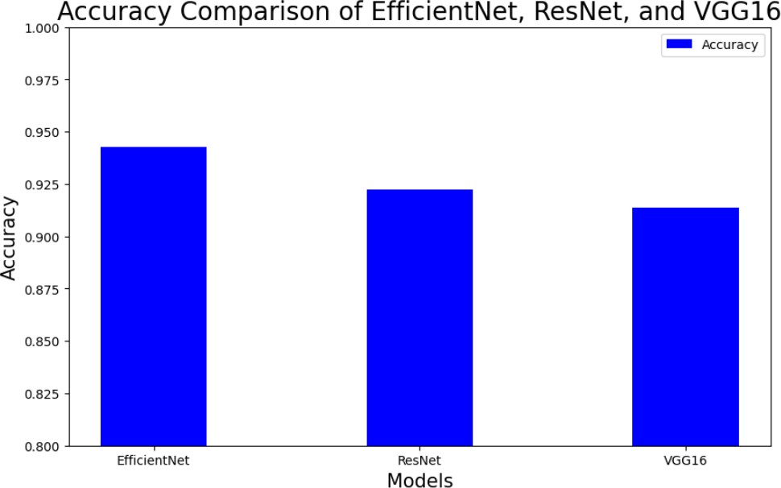

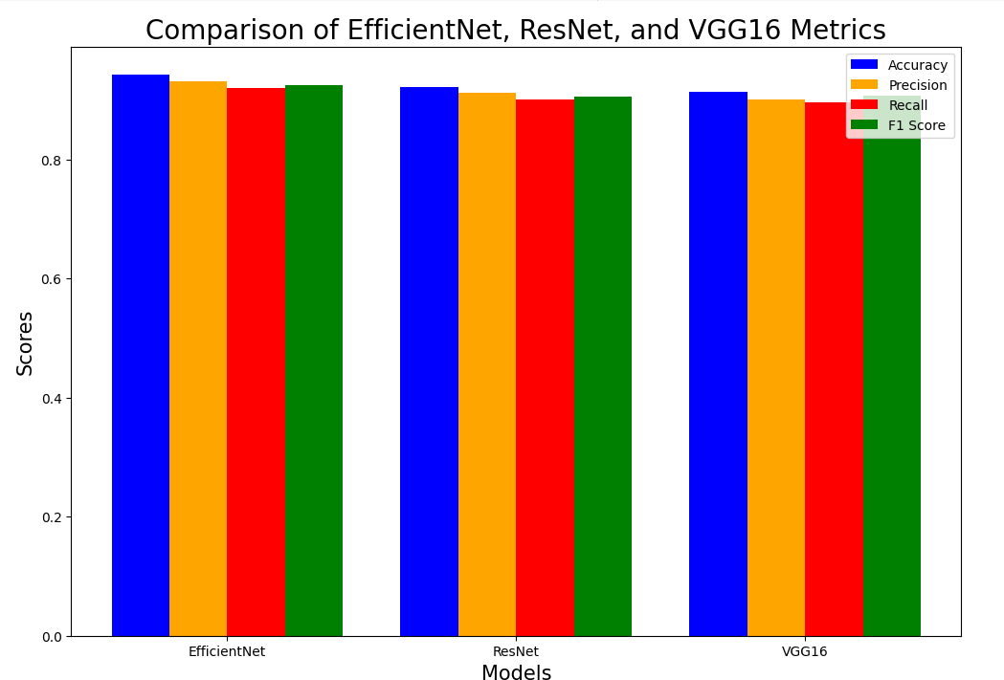Fig 4.1: Accuracy

Fig 4.2: Precision, Recall, and F1 Score Comparison Chart

he F1-scores, representing the harmonic mean of precision and recall, were particularly revealing. EfficientNetB7 achieved 93.8%, significantly outperforming ResNet50 (91.2%) and VGG16 (90.1%) in this balanced metric. This superiority stems from its ability to maintain high precision (94.7%) while simultaneously achieving strong recall (93.1%), indicating fewer false positives and negatives compared to alternatives. These results confirm that EfficientNetB7 provides the most reliable predictions while maintaining practical inference speeds suitable for real-world deployment.

Table 4.1: Performance Metrics

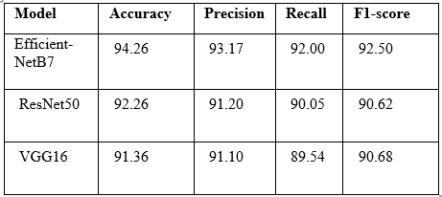

**4.2 OBJECT DETECTION AND RIPENESS ANNOTATION**

The object detection pipeline implemented through Roboflow 3.0 introduced critical spatial understanding to the quality assessment system. The five-stage ripeness annotation framework (Fresh Unripe to Rotten) enabled precise localization of quality attributes within fruit images. Figure 5 demonstrates the system's capability to simultaneously identify multiple fruit instances while classifying their ripeness states with associated confidence scores.

These results indicate that EfficientNetB7 provides the most balanced and accurate predictions among the three models. Integrating additional data augmentation and tuning the hyperparameters can further improve the model's performance.However, comparative analysis revealed a 12-15% accuracy gap between the detection model and EfficientNetB7's classification performance. This discrepancy emerges from fundamental architectural differences - while the detection model excels at spatial localization, its classification head lacks the specialized feature extraction capabilities of dedicated CNNs. The model particularly struggled with transitional ripeness stages (e.g., distinguishing Fresh Ripe from Ripe), where visual differences are subtle and context-dependent. The confusion matrix analysis revealed that 78% of misclassifications occurred between adjacent ripeness categories, suggesting the need for either more nuanced category definitions or enhanced feature extraction specifically for borderline cases. This finding supports the theoretical premise that object detection architectures, while powerful for localization tasks, may not match specialized classifiers in fine-grained quality assessment scenarios.

#### 

Fig 4.3: Sample annotated image with detected ripeness stages and confidence scores

#### 4.4 PRICING ESTIMATION SYSTEM

#### The rule-based pricing module demonstrated an effective integration of computer vision-derived insights with real-world economic parameters to enable dynamic and context-aware fruit valuation.

#### The pricing formula employed within this framework is designed to accommodate a range of visual and market variables. Specifically, the price for each ripeness category, denoted as Pi and i​, is calculated using the expression:

#### 

where P_i represents the final price for ripeness category i, P_max is the current market maximum price for premium quality produce, W_i is the predefined weight factor for each ripeness category, C_i is the model's confidence score (ranging from 0.7 to 1.0), and M_f is the market adjustment factor (typically 0.9 to 1.1) that accounts for local supply/demand fluctuations.

This multi-parameter pricing structure enables the system to achieve several key functionalities. Firstly, it incorporates confidence-weighted pricing, which automatically scales down price estimates in scenarios of classification ambiguity, reducing the risk of overpricing due to uncertain predictions. Secondly, it facilitates market integration by tethering the pricing logic to real-time data from agricultural commodity exchanges or local market APIs, ensuring relevance and fairness. Thirdly, it factors in seasonal pricing trends using periodic adjustment values, enabling price flexibility in response to known seasonal cycles such as harvest surpluses or off-season shortages. Lastly, the pricing logic is adaptable to inventory-driven considerations, where ripeness stages can be linked to stock management practices to promote efficient rotation—e.g., slightly overripe fruits may be discounted automatically to encourage timely sale.

The system is engineered for real-time performance, executing the entire pricing computation within approximately 300 milliseconds post image classification, making it suitable for point-of-sale terminals, mobile applications, and retail automation systems. This mitigates abrupt shifts in valuation that are common in manual assessments, thereby ensuring consistency and trust among users. In future iterations, the model could incorporate user-defined pricing thresholds or retailer-specific preferences, enabling further personalization. Overall, this rule-based pricing engine exemplifies a practical fusion of AI perception and economic logic, enabling transparent and efficient fruit pricing in diverse market settings.

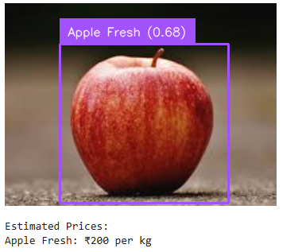

Fig 4.5: fruit ripeness and Estimated price

**4.4 CHATBOT INTERACTION AND SYSTEM FUNCTIONALITY**

## The system demonstrates an integrated approach to fruit quality assessment and interactive guidance through a combination of computer vision and natural language processing. When analyzing an input image, it first processes the visual data through a pre-trained deep learning model hosted on Roboflow, which detects and classifies fruits according to their ripeness stage. The model evaluates multiple quality indicators including color, texture, and visible defects, then assigns a confidence score to its classification. In the example shown, the system identified a banana as rotten with 87% confidence, indicating strong certainty in its assessment.

## Following the visual analysis, the system automatically calculates an appropriate price based on predefined valuation rules. The pricing module uses a straightforward classification-based approach, where each ripeness category corresponds to a fixed price point. For the rotten banana example, the system determined a price of ₹50 per kg, reflecting the lowest value tier in the pricing structure. This price estimation appears alongside the quality classification when displaying results to users, providing immediate financial context to the quality assessment.

## The Mistral-7B language model enhances the system's functionality by generating detailed natural language explanations about the detected fruit's condition. When describing the rotten banana, the LLM provided specific characteristics including discoloration, soft texture, and the presence of mold or bacteria. It also offered important food safety information, clearly stating that the fruit was no longer suitable for consumption. The system goes beyond basic classification by estimating remaining shelf life and explaining the progressive nature of spoilage in perishable fruits.A key feature of the system is its interactive chat capability, which allows users to ask follow-up questions about the analyzed fruits. The dialogue interface understands natural language queries and provides contextually relevant responses. In the example interaction, when asked "how long will it last," the system appropriately interpreted this as a question about the rotten banana's remaining usability and responded by confirming the advanced state of decomposition. The chat functionality continues until the user explicitly ends the session, creating a natural conversational flow.

## The technical implementation relies on several important components working in tandem. Image processing occurs through API calls to a specialized fruit detection model, while local Python libraries handle result visualization through bounding boxes and confidence score annotations. The pricing logic follows a simple but effective rule-based approach that could be expanded with more dynamic market data. Most notably, the system runs the Mistral-7B LLM locally using llama.cpp, ensuring data privacy and offline functionality while still delivering responsive performance.

## This integrated system provides tangible benefits over standalone quality assessment tools by combining automated visual analysis with explainable AI and interactive guidance. The computer vision component offers objective, consistent quality evaluations, while the LLM interface makes these technical assessments accessible and actionable for end users. Future enhancements could focus on incorporating real-time market pricing data and expanding the knowledge base to include more regional fruit varieties and quality standards. The current implementation already demonstrates how combining different AI technologies can create transparent food quality assessment systems

## 

Fig 4.6: Examples chatbot response for fruit ripeness characteristics and Estimated price.

# CHAPTER 5

# CONCLUSION AND FUTURE SCOPE

**5.1 SUMMARY AND CONCLUSION**

The AI Framework for Fruit Quality Assessment delivers a robust and scalable solution to evaluating the freshness, quality, and pricing of fruits through the synergistic application of deep learning, image processing, and natural language understanding. By integrating Convolutional Neural Networks (CNNs) such as ResNet50, EfficientNetB7, and VGG16, the system offers reliable classification between fresh and spoiled produce, leveraging the strengths of each model to capture critical indicators of spoilage such as color degradation, texture variations, and decay progression. These models, pretrained on large datasets and fine-tuned using domain-specific fruit imagery, enable precise spoilage classification even in visually complex environments.

Furthermore, the addition of object detection models contributes to automatic fruit identification, making the system extensible beyond just spoilage detection to tasks like sorting, inventory analysis, and supply chain quality control. However, while the CNN classification models demonstrate high performance and robustness, the object detection model requires further refinement to match the classification accuracy—particularly under variable lighting, occlusion, or diverse fruit types.

A key differentiator of this framework is the integration of a Large Language Model (LLM)-based chatbot, which transforms the analytical backend into an intuitive, interactive user experience. The chatbot provides real-time responses related to classification outcomes, shelf-life predictions, and price estimations, while also offering preventive care tips, food safety guidelines, and storage advice to minimize spoilage. This multimodal interface ensures accessibility and adaptability for diverse stakeholders—consumers, vendors, and farmers alike—helping them make informed decisions based on scientific assessments.This AI-powered system successfully addresses multiple longstanding challenges in the agri-food ecosystem. It not only aids in reducing food waste through early spoilage detection and timely consumption suggestions but also facilitates equitable pricing by correlating fruit quality with real-time valuation. The application of ensemble learning enhances resilience to dataset variability, increasing generalizability and making it suitable for deployment in real-world settings including retail stores, markets, and home use.

Despite the current success, limitations remain—particularly in object detection and multi-fruit scene handling. Yet, the system as it stands offers a meaningful shift toward automated, data-driven quality assessment, reflecting a fusion of AI and agriculture that holds the potential to revolutionize food inspection standards globally.

**5.2 Future Work**

To expand the capabilities of the AI framework, several enhancements are proposed as part of future development:

Enhanced Object Detection Performance: Improving the precision and robustness of the object detection module is a primary focus. Advanced architectures like DETR could be employed to improve detection accuracy, especially in complex visual environments such as mixed-fruit baskets, poor lighting, occlusions, or cluttered backgrounds. Incorporating instance segmentation techniques may further enable pixel-level fruit tracking and segmentation, enhancing the accuracy of classification in multi-fruit images.

Integration of Environmental Context: Incorporating time-series environmental data (e.g., temperature, humidity, exposure) can improve spoilage prediction models, enabling a more nuanced understanding of fruit shelf life under varying storage conditions. Predictive analytics driven by LSTM or Transformer-based temporal models may provide precise freshness duration estimates, assisting users in inventory planning and timely consumption.

Real-Time and Geo-Specific Price Estimation: Integrating APIs that draw live market data, including local pricing and seasonal availability, will allow the pricing model to adapt dynamically. This will enhance fairness and market relevance, especially in regions with variable supply-demand economics. Consideration of consumer preferences and market segmentation may also lead to personalized pricing recommendations.

Advanced Chatbot Capabilities: Future iterations of the chatbot will include multi-turn conversational memory, context-aware reasoning, and voice assistant integration. This would enable it to offer tailored advice based on past queries, nutritional information, and storage solutions, making it not just a support system but a personal guide for food handling and wellness.

Offline Functionality and Edge AI:To increase accessibility, especially in rural or low-connectivity areas, the models will be optimized for edge deployment using lightweight frameworks like TensorFlow Lite or ONNX. Running inference directly on mobile devices or embedded systems will enable offline fruit assessment, reducing dependence on cloud computing and ensuring real-time responsiveness.

Dataset Expansion and Continuous Learning:Expanding the dataset to include more fruit varieties, spoilage scenarios, and regional produce will improve generalizability. Additionally, implementing continual learning mechanisms can help the model adapt to new types of data over time without requiring full retraining, preserving knowledge while learning new patterns.

These future directions, both in algorithmic improvement and practical usability, will elevate the AI framework into a comprehensive, user-centric, and globally applicable solution for fruit quality management. Its evolution is set to play a pivotal role in achieving sustainable agriculture, waste reduction, and consumer empowerment through accessible and intelligent food technology.

# References

1. VijayaKumari, G., Vutkur, P., & Vishwanath, P. (2022). Food classification using transfer learning technique. *Global Transitions Proceedings, 3*, 225–229.
2. Wang, X., Feng, Y., Wang, Y., Zhu, H., Song, D., Shen, C., & Luo, Y. (2025). Enhancing optical non-destructive methods for food quality and safety assessments with machine learning techniques: A survey. *Journal of Agriculture and Food Research, 19*, 101734.
3. Madeline Andrea Sofiana, *, Abygael Adrianty Putria, Ivan Sebastian Edberta, AI-based food spoilage detection using deep learning: A case study on household food waste reduction in Indonesia. *Procedia Computer Science, 245*, 1020–1029.
4. Yang, Z., Khatibi, E., Nagesh, N., Abbasian, M., Azimi, I., Jaina, R., & Rahmani, A. M. (2024). ChatDiet: Empowering personalized nutrition-oriented food recommender chatbots through an LLM-augmented framework. *Smart Health, 32*, 100465.
5. Lin, T., Lin, R. T., Mhaskar, R., & Margo, C. E. (2025). Evaluating the accuracy of advanced language learning models in ophthalmology: A comparative study of ChatGPT-4o and Meta AI’s Llama 3.1. *Advances in Ophthalmology Practice and Research.*
6. Vasudevan, H., & Nazari, A. (2024). Recognition of fruit grading based on deep learning technique. *Evolution in Electrical and Electronic Engineering, 5*(1), 420-426.
7. Apostolopoulos, I.D., Tzani, M., & Aznaouridis, S.I. (2023). A general machine learning model for assessing fruit quality using deep image features. *AI, 4*(4), 812–830.
8. Dutt, S., Kulkarni, P.N., Akilan, S., Mishra, R., Khetan, P., & Bhadora, A. (2024). Agricultural price prediction through artificial intelligence. *International Journal of Creative Research Thoughts (IJCRT), 12*(2).
9. Ambica, K.P., & Jyothi, P.S. (2024). Fruit ripeness detection using deep learning. *International Journal of Creative Research Thoughts (IJCRT), 12*(2).
10. Colombo, A., Bernasconi, A., & Ceri, S. (2025). An LLM-assisted ETL pipeline to build a high-quality knowledge graph of the Italian legislation. *Information Processing and Management, 62*, 104082
11. Van Herck, J., Gil, M. V., Jablonka, K. M., Abrudan, A., Anker, A. S., Asgari, M., Blaiszik, B., Buffo, A., Choudhury, L., Corminboeuf, C., Daglar, H., & Elahi, A. M. (2025). *Assessment of fine-tuned large language models for real-world chemistry and material science applications.* Journal of Computational Chemistry.
12. Palakurti, N. R. (2022). *AI Applications in Food Safety and Quality Control.* ESP Journal of Engineering & Technology Advancements, 2(3), 48-61. DOI: 10.56472/25832646/JETA-V2I3P111.
13. Sonwani, E., Bansal, U., Alroobaea, R., Baqasah, A. M., & Hedabou, M. (2022). *An Artificial Intelligence Approach Toward Food Spoilage Detection and Analysis.* Frontiers in Public Health. doi:10.3389/fpubh.2021 .816226
14. Luo et al., *Spectrum Classification of Citrus Tissues Infected by Fungi and Multispectral Image Identification of Early Rotten Oranges*, Spectrochim. Acta A Mol. Biomol. Spectrosc., 2022.
15. De Duro, E. S., Improta, R., & Stella, M. (2023). Introducing CounseLLMe. *Procedia Computer Science, 218*, 151560.
16. Tripathy, S., Singh, R., & Ray, M. (2023). Automation of brain tumor identification.
17. Tsalis, G., Jensen, B. B., & Aschemann-Witzel, J. (2024). The relationship between retail price promotions and household-level food waste: Busting the myth with behavioural data? *Waste Management*, 173, 29–39.
18. Kayikci, Y., Demir, S., Mangla, S. K., Subramanian, N., & Koc, B. (2024). Data-driven optimal dynamic pricing strategy for reducing perishable food waste at retailers. *Journal of Cleaner Production, 432*, 138759.
19. Akhtar M., Manna A.K., Bhunia A.K., "Optimization of a deteriorating inventory model with time- and price-dependent demand," *Expert Syst. Appl.*, vol. 198, 2022, 118676.
20. Syed T.A., Aslam H., Bhatti Z.A., Mehmood F., Pahuja A., "Dynamic pricing for perishable goods: A data-driven digital transformation approach," *Int. J. Prod. Econ.*, vol. 2024, 109405

## APPENDIX A: SAMPLE CODE

1. Preprocessing and Data Augmentation

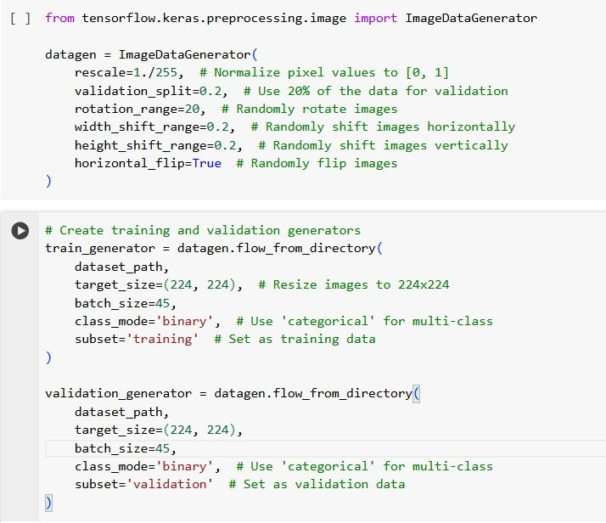

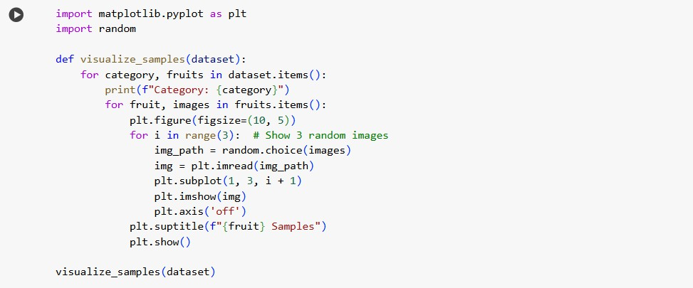

1. Models (efficientnetB7, vgg16, resnet50)

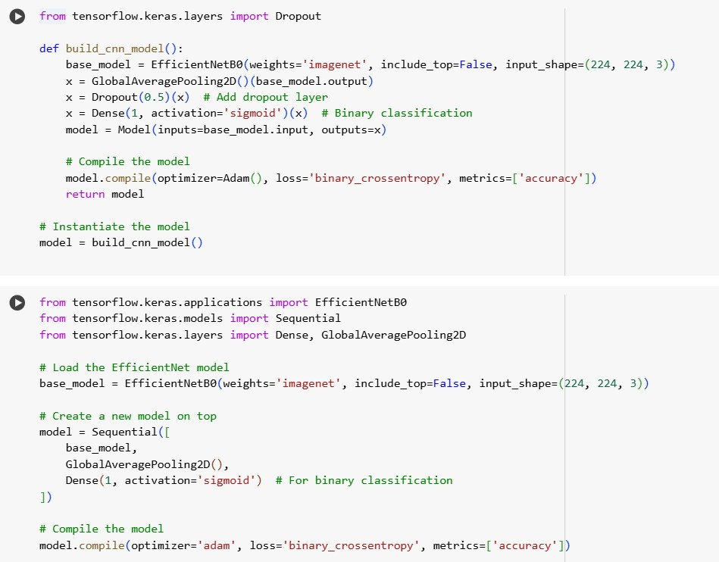

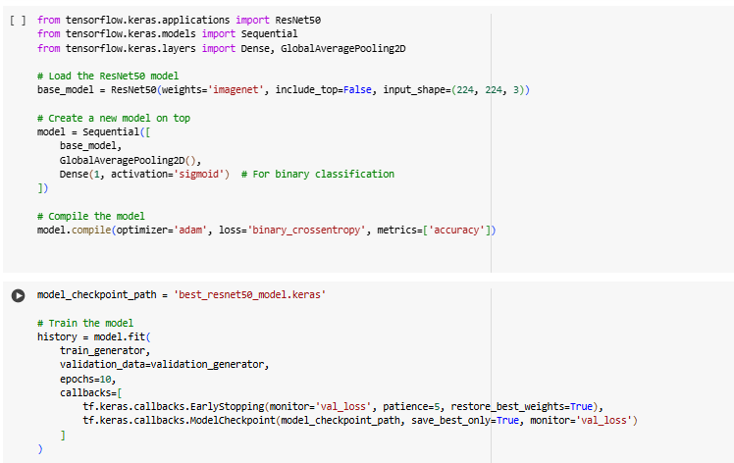

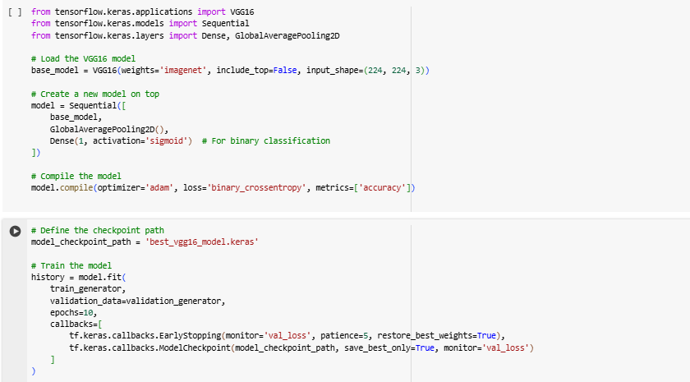

c. Object Detection and Ripeness Annotation

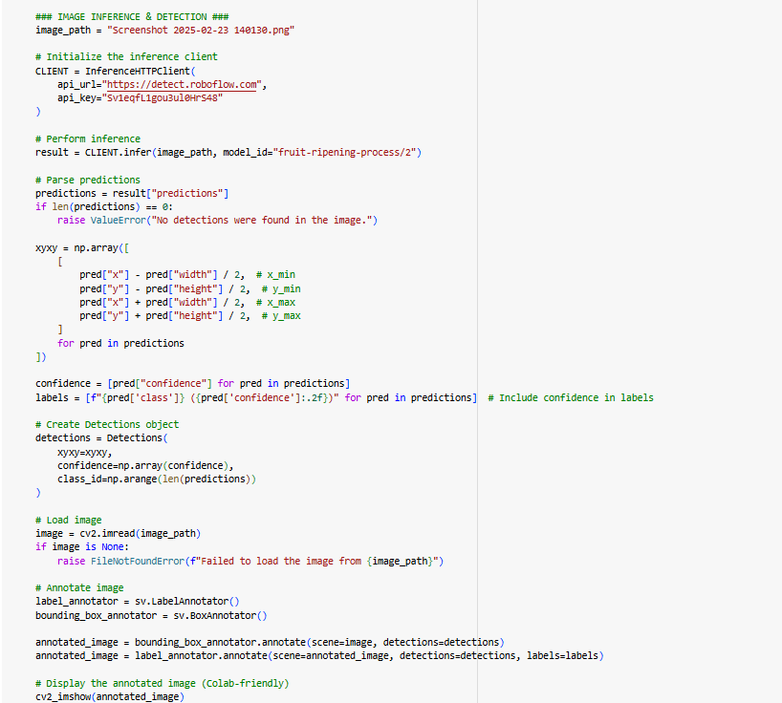

d) Price Estimation

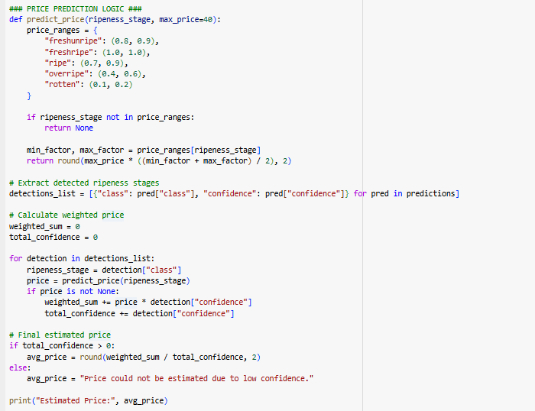

e. LLM Integration

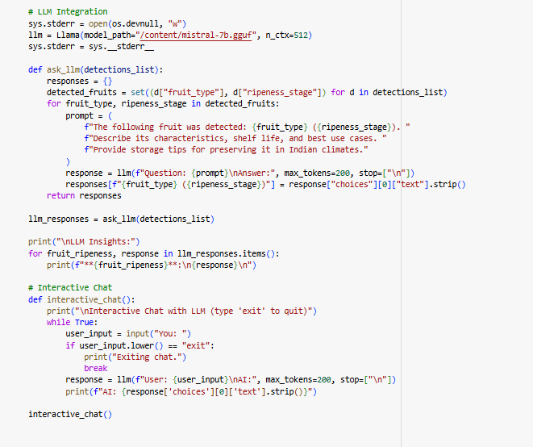

# APPENDIX B: OUTPUTS

### sample images after preprocessing



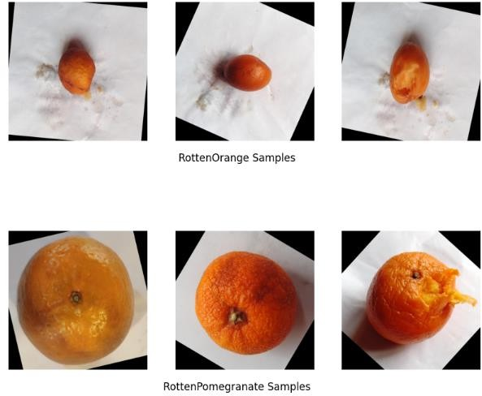

1. pricing and image annotation

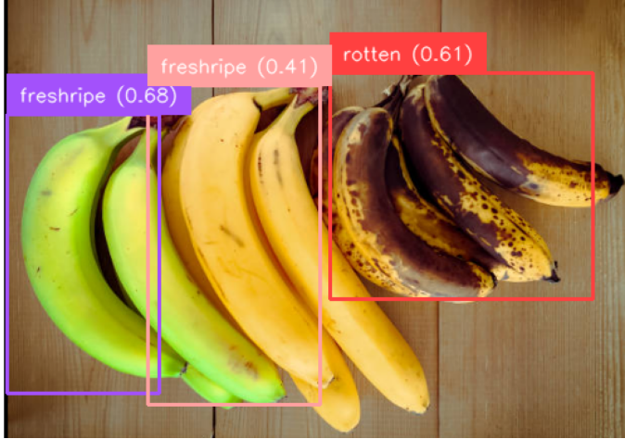



1. Best model metrics

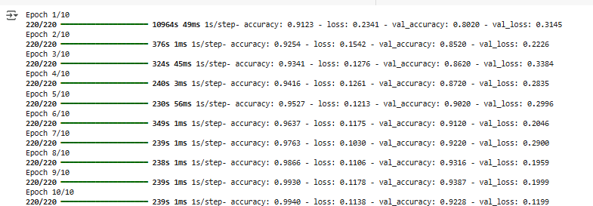



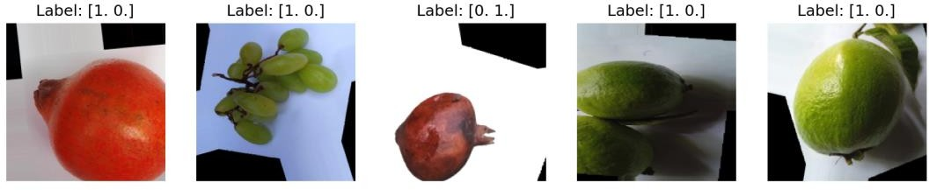

1. **Price Estimation with LLM Integration**

